Inscribed Angle
# Source: AI Source: Provided by: [Data Path: Persons Table -> ID Column: 1, Name_En Column: Motasem Essam] -> From: [ChatGPT] on [7/25/2026]
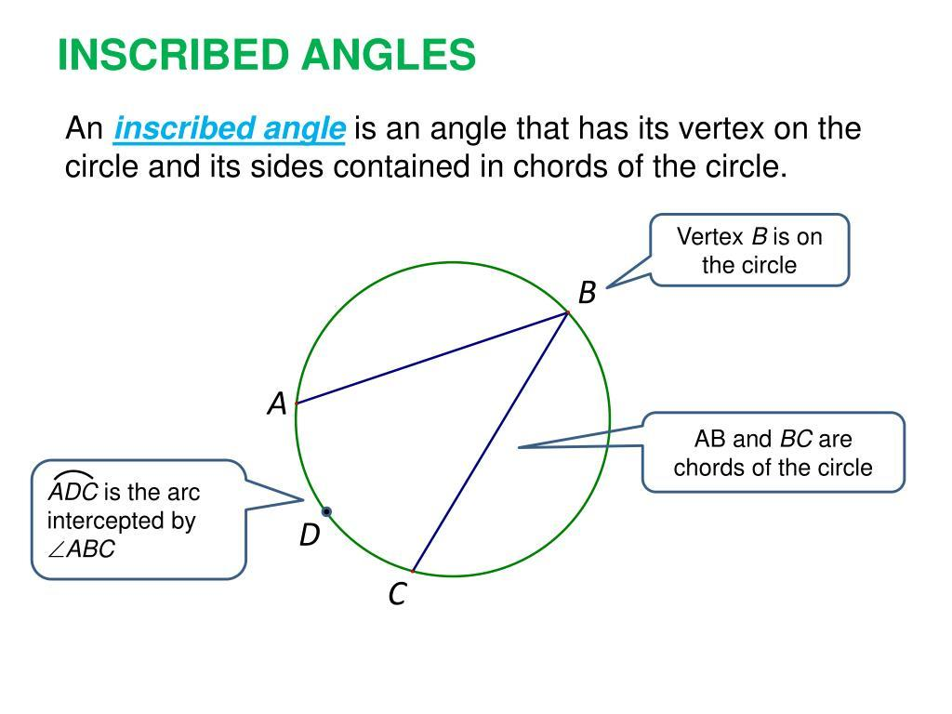
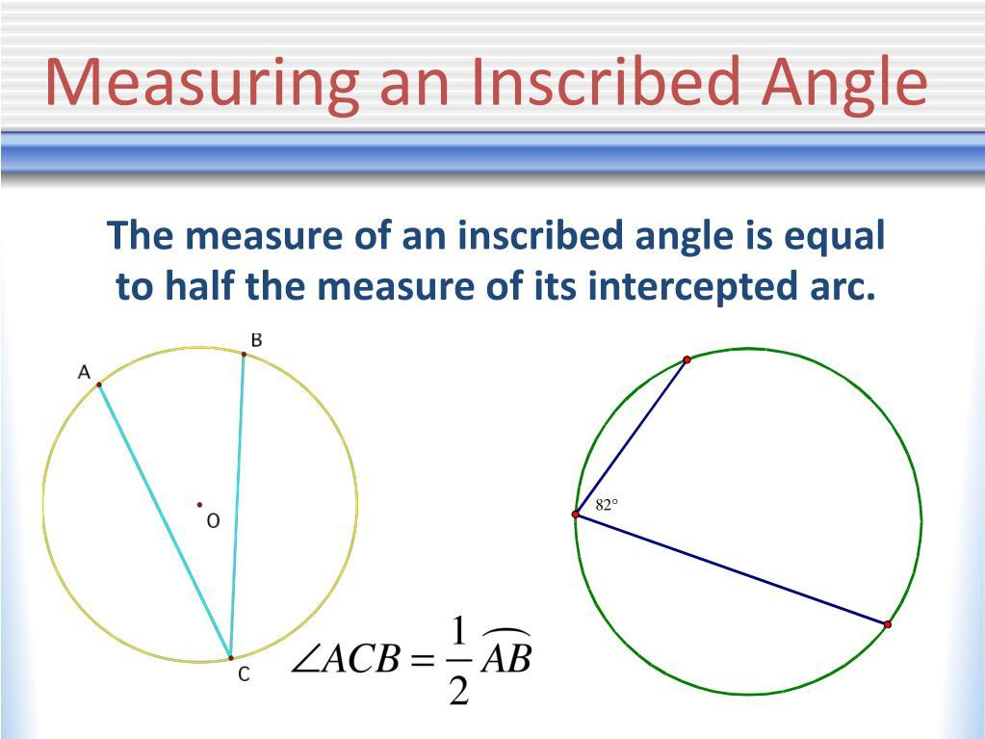
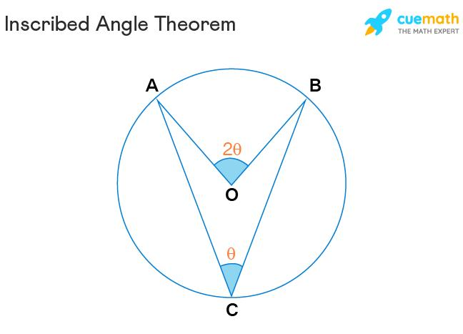
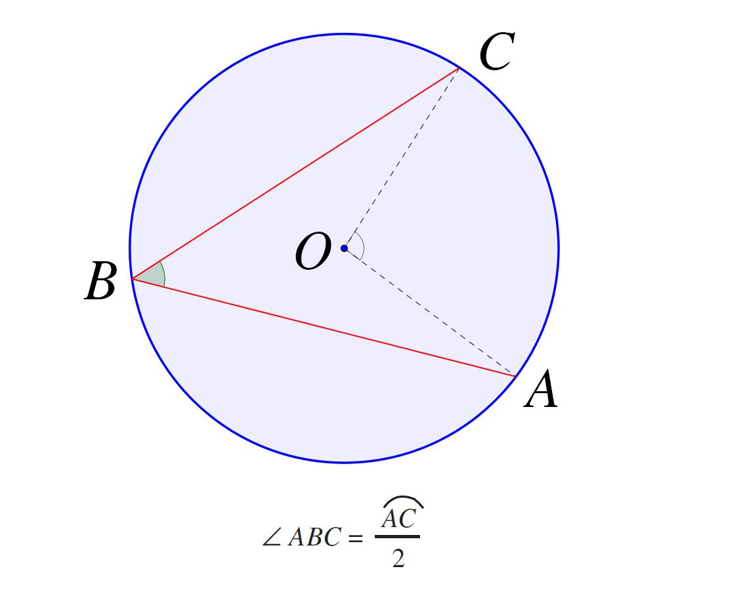

Definition
# Source: AI Source: Provided by: [Data Path: Persons Table -> ID Column: 1, Name_En Column: Motasem Essam] -> From: [ChatGPT] on [7/25/2026]
An Inscribed Angle is an angle whose vertex lies on the circumference of a circle and whose two sides are chords of the circle.
For points $A$, $B$, and $C$on a circle:
$$∠ACB$$
is an inscribed angle because:
- $C$lies on the circumference.
- $\overset{‾}{CA}$is a chord.
- $\overset{‾}{CB}$is a chord.
The arc opposite the vertex is called the intercepted arc.

Fundamental Concept
# Source: AI Source: Provided by: [Data Path: Persons Table -> ID Column: 1, Name_En Column: Motasem Essam] -> From: [ChatGPT] on [7/25/2026]
An inscribed angle measures half of the measure of its intercepted arc.
$$\boxed{m\left(∠ACB\right)=\frac{1}{2}m\left(\hat{AB}\right)}$$
Equivalently:
$$\boxed{m\left(\hat{AB}\right)=2m\left(∠ACB\right)}$$
This is known as the Inscribed Angle Theorem.

Main Parts
# Source: AI Source: Provided by: [Data Path: Persons Table -> ID Column: 1, Name_En Column: Motasem Essam] -> From: [ChatGPT] on [7/25/2026]
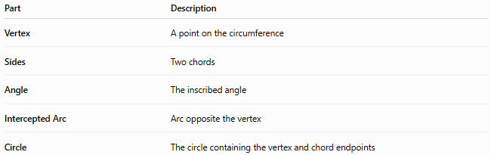
Part | Description
Vertex | A point on the circumference
Sides | Two chords
Angle | The inscribed angle
Intercepted Arc | Arc opposite the vertex
Circle | The circle containing the vertex and chord endpoints
Example:
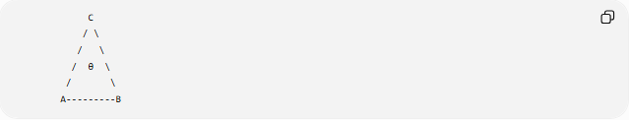
C
/ \
/ \
/ θ \
/ \
A---------B
Here:
- $C$= vertex
- $\overset{‾}{CA}$and $\overset{‾}{CB}$= chords
- $∠ACB$= inscribed angle
- $\hat{AB}$= intercepted arc

Inscribed Angle Theorem
# Source: AI Source: Provided by: [Data Path: Persons Table -> ID Column: 1, Name_En Column: Motasem Essam] -> From: [ChatGPT] on [7/25/2026]
For an inscribed angle $∠ACB$:
$$\boxed{m\left(∠ACB\right)=\frac{1}{2}m\left(\hat{AB}\right)}$$
Example
If:
$$m\left(\hat{AB}\right)={120}^{∘}$$
then:
$$m\left(∠ACB\right)=\frac{{120}^{∘}}{2} \\ \boxed{m\left(∠ACB\right)={60}^{∘}}$$

Relationship with a Central Angle
# Source: AI Source: Provided by: [Data Path: Persons Table -> ID Column: 1, Name_En Column: Motasem Essam] -> From: [ChatGPT] on [7/25/2026]
A central angle and an inscribed angle can intercept the same arc.
For example:
$$∠AOB$$
is a central angle, while:
$$∠ACB$$
is an inscribed angle.
If both intercept $\hat{AB}$, then:
$$\boxed{m\left(∠AOB\right)=2m\left(∠ACB\right)}$$
Therefore:
$$\boxed{m\left(∠ACB\right)=\frac{1}{2}m\left(∠AOB\right)}$$

Equal Inscribed Angles
# Source: AI Source: Provided by: [Data Path: Persons Table -> ID Column: 1, Name_En Column: Motasem Essam] -> From: [ChatGPT] on [7/25/2026]
Inscribed angles that intercept the same arc are equal.
If both $∠ACB$and $∠ADB$intercept the same arc $\hat{AB}$, then:
$$\boxed{m\left(∠ACB\right)=m\left(∠ADB\right)}$$
provided their vertices lie on the same appropriate arc of the circle.
This property is sometimes described as:
Angles in the same segment of a circle are equal.

Inscribed Angle Subtending a Diameter
# Source: AI Source: Provided by: [Data Path: Persons Table -> ID Column: 1, Name_En Column: Motasem Essam] -> From: [ChatGPT] on [7/25/2026]
When an inscribed angle intercepts a diameter, the angle is a right angle.
This is Thales' theorem:
$$\boxed{m\left(∠ACB\right)={90}^{∘}}$$
when $\overset{‾}{AB}$is a diameter.
Since the diameter subtends a semicircular arc:
$$m\left(\hat{AB}\right)={180}^{∘}$$
and therefore:
$$m\left(∠ACB\right)=\frac{1}{2}\left({180}^{∘}\right)={90}^{∘}$$
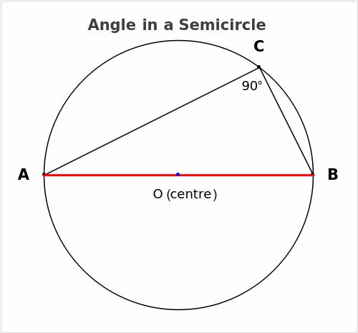
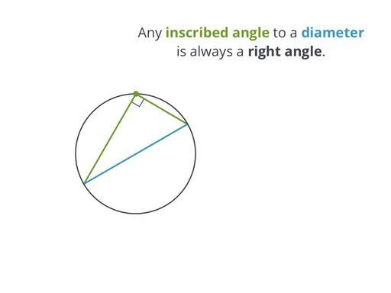
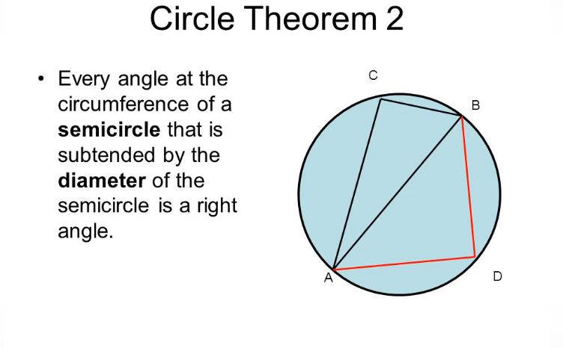
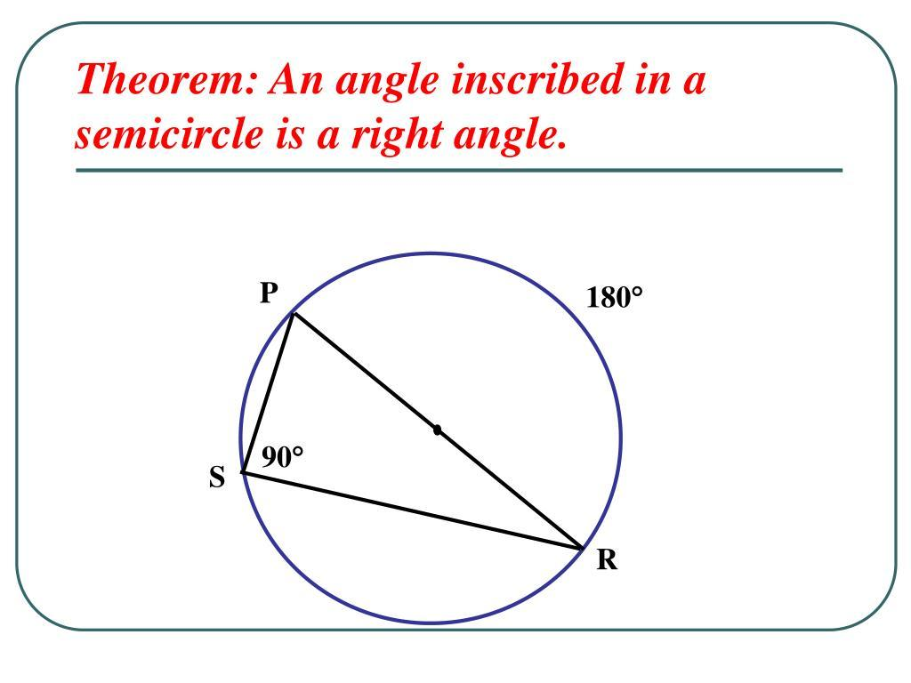
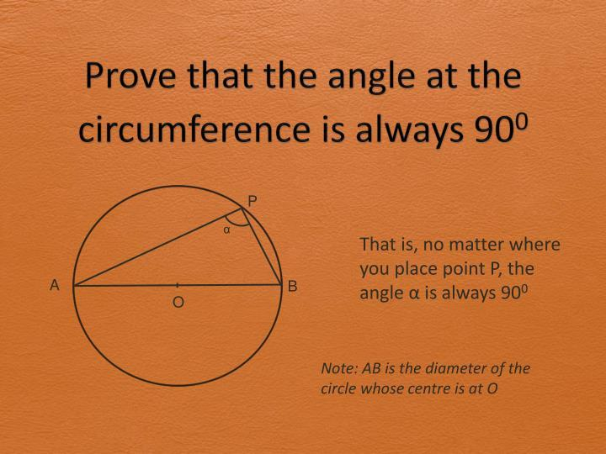

Types of Inscribed Angles
# Source: AI Source: Provided by: [Data Path: Persons Table -> ID Column: 1, Name_En Column: Motasem Essam] -> From: [ChatGPT] on [7/25/2026]
Inscribed angles can be classified according to their measure:
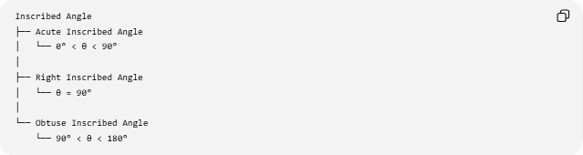
Inscribed Angle
├── Acute Inscribed Angle
│ └── 0° < θ < 90°
│
├── Right Inscribed Angle
│ └── θ = 90°
│
└── Obtuse Inscribed Angle
└── 90° < θ < 180°
An inscribed angle cannot be ${180}^{∘}$in a non-degenerate configuration because its two chord sides would become collinear.

Inscribed Angle and Arc Types
# Source: AI Source: Provided by: [Data Path: Persons Table -> ID Column: 1, Name_En Column: Motasem Essam] -> From: [ChatGPT] on [7/25/2026]
Because an inscribed angle is half its intercepted arc:
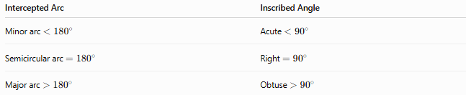
Intercepted Arc | Inscribed Angle
Minor arc $<{180}^{∘}$ | Acute $<{90}^{∘}$
Semicircular arc $={180}^{∘}$ | Right $={90}^{∘}$
Major arc $>{180}^{∘}$ | Obtuse $>{90}^{∘}$
Thus:
$$\boxed{\text{Inscribed angle}=\frac{1}{2}\left(\text{intercepted arc}\right)}$$

Example: Minor Arc
# Source: AI Source: Provided by: [Data Path: Persons Table -> ID Column: 1, Name_En Column: Motasem Essam] -> From: [ChatGPT] on [7/25/2026]
Suppose:
$$m\left(\hat{AB}\right)={80}^{∘}$$
Then:
$$m\left(∠ACB\right)=\frac{1}{2}\left({80}^{∘}\right) \\ \boxed{m\left(∠ACB\right)={40}^{∘}}$$
The angle is acute.

Example: Semicircular Arc
# Source: AI Source: Provided by: [Data Path: Persons Table -> ID Column: 1, Name_En Column: Motasem Essam] -> From: [ChatGPT] on [7/25/2026]
Suppose $AB$is a diameter.
Then:
$$m\left(\hat{AB}\right)={180}^{∘}$$
Therefore:
$$m\left(∠ACB\right)=\frac{1}{2}\left({180}^{∘}\right) \\ \boxed{m\left(∠ACB\right)={90}^{∘}}$$

Example: Major Arc
# Source: AI Source: Provided by: [Data Path: Persons Table -> ID Column: 1, Name_En Column: Motasem Essam] -> From: [ChatGPT] on [7/25/2026]
Suppose the intercepted major arc measures:
$$m\left(\hat{AB}\right)={240}^{∘}$$
Then:
$$m\left(∠ACB\right)=\frac{1}{2}\left({240}^{∘}\right) \\ \boxed{m\left(∠ACB\right)={120}^{∘}}$$
Therefore, the inscribed angle is obtuse.

Inscribed Angle and Circle Geometry
# Source: AI Source: Provided by: [Data Path: Persons Table -> ID Column: 1, Name_En Column: Motasem Essam] -> From: [ChatGPT] on [7/25/2026]
Inscribed angles connect several important circle concepts:
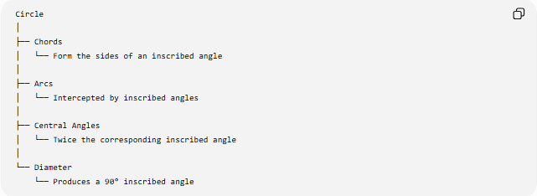
Circle
│
├── Chords
│ └── Form the sides of an inscribed angle
│
├── Arcs
│ └── Intercepted by inscribed angles
│
├── Central Angles
│ └── Twice the corresponding inscribed angle
│
└── Diameter
└── Produces a 90° inscribed angle

Inscribed Angle vs Central Angle
# Source: AI Source: Provided by: [Data Path: Persons Table -> ID Column: 1, Name_En Column: Motasem Essam] -> From: [ChatGPT] on [7/25/2026]
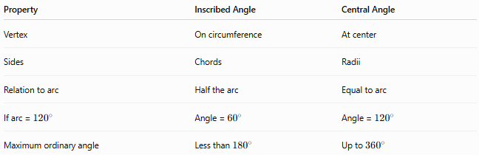
Property | Inscribed Angle | Central Angle
Vertex | On circumference | At center
Sides | Chords | Radii
Relation to arc | Half the arc | Equal to arc
If arc = ${120}^{∘}$ | Angle = ${60}^{∘}$ | Angle = ${120}^{∘}$
Maximum ordinary angle | Less than ${180}^{∘}$ | Up to ${360}^{∘}$

Inscribed Angle vs Chord
# Source: AI Source: Provided by: [Data Path: Persons Table -> ID Column: 1, Name_En Column: Motasem Essam] -> From: [ChatGPT] on [7/25/2026]
An inscribed angle is formed by two chords.
A chord itself is simply a line segment whose endpoints lie on the circumference.
Therefore:
$$\boxed{\text{Two chords meeting on the circumference form an inscribed angle.}}$$

Mathematical Relationships
# Source: AI Source: Provided by: [Data Path: Persons Table -> ID Column: 1, Name_En Column: Motasem Essam] -> From: [ChatGPT] on [7/25/2026]
Arc
$$\boxed{m\left(∠ACB\right)=\frac{1}{2}m\left(\hat{AB}\right)}$$
Central Angle
$$\boxed{m\left(∠AOB\right)=2m\left(∠ACB\right)}$$
Diameter
$$\boxed{AB\text{ is a diameter}⇒m\left(∠ACB\right)={90}^{∘}}$$
Equal Angles
If two inscribed angles intercept the same arc:
$$\boxed{m\left(∠ACB\right)=m\left(∠ADB\right)}$$

Important Special Cases
# Source: AI Source: Provided by: [Data Path: Persons Table -> ID Column: 1, Name_En Column: Motasem Essam] -> From: [ChatGPT] on [7/25/2026]
Case 1 — Same Arc
Inscribed angles intercepting the same arc are equal.
Case 2 — Diameter
An inscribed angle subtending a diameter is ${90}^{∘}$.
Case 3 — Semicircular Arc
A ${180}^{∘}$arc produces a ${90}^{∘}$inscribed angle.
Case 4 — Central and Inscribed Angles
For the same intercepted arc:
$$\text{Central Angle}=2\left(\text{Inscribed Angle}\right)$$

Key Points
# Source: AI Source: Provided by: [Data Path: Persons Table -> ID Column: 1, Name_En Column: Motasem Essam] -> From: [ChatGPT] on [7/25/2026]
- An Inscribed Angle has its vertex on the circumference.
- Its sides are chords.
- It measures half of its intercepted arc.
- A central angle intercepting the same arc is twice the inscribed angle.
- Inscribed angles intercepting the same arc are equal.
- An inscribed angle subtending a diameter is always ${90}^{∘}$.
- A minor arc produces an acute inscribed angle.
- A semicircular arc produces a right inscribed angle.
- A major arc produces an obtuse inscribed angle.

Conclusion
# Source: AI Source: Provided by: [Data Path: Persons Table -> ID Column: 1, Name_En Column: Motasem Essam] -> From: [ChatGPT] on [7/25/2026]
An Inscribed Angle is a fundamental angle in circle geometry formed by two chords whose common endpoint lies on the circumference. Its most important property is the Inscribed Angle Theorem: the measure of an inscribed angle is half the measure of its intercepted arc. This relationship provides the foundation for understanding angles in circles, equal angles in the same segment, Thales' theorem, and the relationship between central angles and inscribed angles.

